**Practical no 8 :Query based on operators and joins .simple nested query**

**NAME: Tushar Vishal Charavande Roll No:25**

**Div: A Batch no: B1**

select * from Employees;

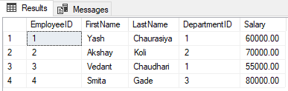

Department Table:

select * from Departments;

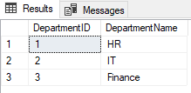

Simple Query with Joins:

SELECT e.EmployeeID,e.FirstName,e.LastName,e.Salary,d.DepartmentName

FROM Employees e JOIN

Departments d ON e.DepartmentID = d.DepartmentID;

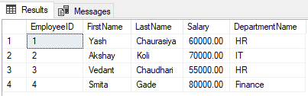

Nested Query with Operators:

SELECT EmployeeID, FirstName, LastName,Salary,DepartmentID

FROM Employees WHERE Salary > (SELECT AVG(Salary) FROM Employees WHERE

DepartmentID = Employees.DepartmentID);

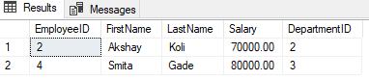

**Practical 7 :- Demonstrate use of operators.**

**NAME: Tushar Vishal Charavande Roll No:25**

**Div: A Batch no: B1**

/*Arithmetic Operators:

Addition*/

SELECT 25 + 10 AS AdditionResult;

--Subtraction*/

SELECT 43 - 5 AS SubtractionResult;

--Multiplication

SELECT 7 * 7 AS MultiplicationResult;

--Division

SELECT 25 / 5 AS DivisionResult;

--Modulus (remainder of division)

SELECT 18 % 7 AS ModulusResult;

**Output:-**

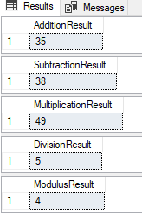

--Comparison Operators:

--Equal to

SELECT * FROM employee WHERE emp_salary = 1000;

--Not equal to

SELECT * FROM employee WHERE dep_id <> 2;

--Greater than

SELECT * FROM employee WHERE emp_salary > 10000;

--Less than

SELECT * FROM employee WHERE emp_salary < 10000;

--Greater than or equal to

SELECT * FROM employee WHERE emp_salary >= 1000;

--Less than or equal to

SELECT * FROM employee WHERE emp_salary <= 10000.00;

**Output:**

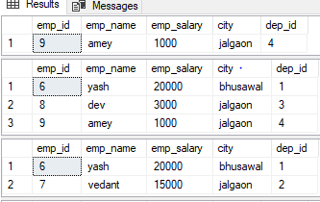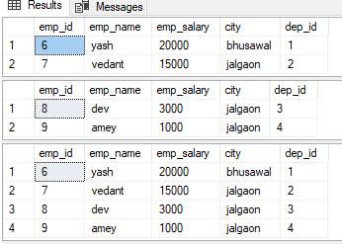

--Logical Operators:

--AND

SELECT * FROM employee WHERE emp_salary > 10000 and emp_id = '6';

--OR

SELECT * FROM employee WHERE emp_name='dev' OR emp_salary < 1000;

--NOT

SELECT * FROM employee WHERE NOT emp_id = '9';

--Range query with BETWEEN

SELECT * FROM employee WHERE emp_salary BETWEEN 3000 AND 20000;\

**Output:**

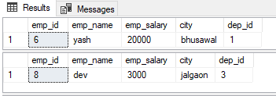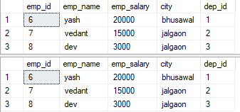

**Practical 10**: Write down SQL by using i. Aggregate functions ii. Date functions iii. String functions.

**NAME: Tushar Vishal Charavande Roll No:25**

**Div: A Batch no: B1**

Aggregate functions:

select count(emp_salary) as count from e123;

select min(emp_salary) as min from e123;

select max(emp_salary) as max from e123;

select avg(emp_salary) as avg from e123;

select sum(emp_salary) as sum from e123;

select*from e123;

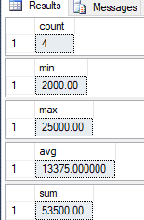



Date functions

select GETDATE() as Date

select datediff(year,'2024/02/29','2016/05/7') as datediff

select datename(mm,'2024/12/12') as datepartstring

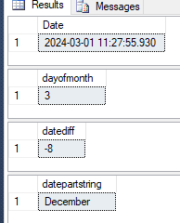

select day ('2024/03/20') as dayofmonth

select dateadd(year,10,'2024/04/25') as dateadd

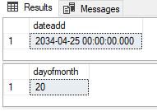

**String function:**

select concat('model',' ','price') as concat

select len('hello world') as length

select reverse('database management system') as reverse

select str(149.8) as string

select upper('sql database') as upper

select LOWER('sql database') as lower

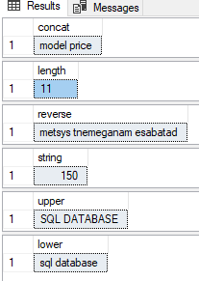

**Practical no 9: write down sql by using WHERE CLAUSE GROUP BY HAVING CLAUSE**

**NAME: Tushar Vishal Charavande Roll No:25**

**Div: A Batch no: B1**

select*from employee;

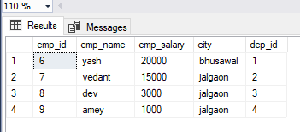

1. WHERE CLAUSE :

select emp_name,emp_salary from employee where emp_salary !=5000 group by emp_name,emp_salary;

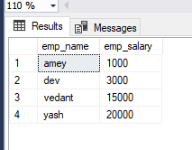

1. GROUP BY:

select emp_name,emp_salary,count(*) from employee group by emp_name,emp_salary;

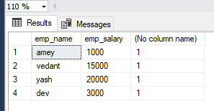

1. HAVING CLAUSE:

select emp_name,emp_salary from employee group by emp_name,emp_salary having (emp_salary)>11000;

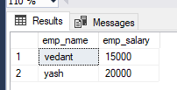

**PRACTICLE 4:- DEMONSTRATE TO SELECT IN CLAUSE**

**NAME: Tushar Vishal Charavande Roll No:25**

**Div: A Batch no: B1**

**Order by Descending:**

use Collegestudentsdb;

select top 3* from employees

where (ID>1)

order by first_name desc

**output:-**

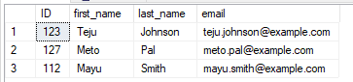

**Order by Ascending:**

use Collegestudentsdb;

select top 3* from employees

where (ID>1)

order by first_name asc

**Output:**

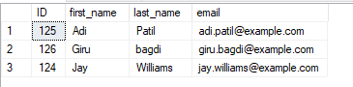

**PRACTICLE 6:- Demonstrate integrity constraints (primary keys,Foreign key,check,Default)**

**NAME: Tushar Vishal Charavande Roll No:25**

**Div: A Batch no: B1**

use Collegestudentsdb;

create table dept1 (deptid int primary key,deptname varchar (50));

insert into dept1 values (1,'BCA');

insert into dept1 values (2,'Cybersecurity');

insert into dept1 values (3,'MCA');

select *from dept1;

**output:-**

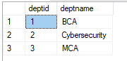

create table employee2 (id int not null primary key,

name varchar (50) not null,

salary varchar (50) check (salary>0),

address varchar (50) default 'Bhusawal',

deptid int foreign key references dept1(deptid));

insert into employee2 values (1,'Girish',50000,'Jalgaon',1);

insert into employee2 values (2,'Kaveri',30000,'Jalgaon',2);

insert into employee2 values (3,'Gaurav',20000,'Jalgaon',3);

select *from employee2;

**Output:**

